# Exercises about classes and inheritance

* Solve them in Visual Studio.

## Exercise 13.01

* The namespace of your project is “Persons”.
* You make a class “Person”.
  + 6 variables.
    - name (string).
    - birthDate (DateTime).
    - street (string).
    - houseNumber (string).
    - zipcode (string).
    - city (string).
  + 7 properties.
    - Name (string).
    - BirthDate (DateTime).
    - Street (string).
    - HouseNumber (string).
    - ZipCode (string).
    - City (string).
    - Address (string) (Dynamic property).
      * This consists of more than one variable.
      * street + space + houseNumber + jump to new line + zipcode + space + city.
  + You have to determine by yourself what needs a get and / or a set.
  + One constructor with 6 parameters.
    - name (string).
    - birthDate (DateTime).
    - street (string).
    - houseNumber (string).
    - zipcode (string).
    - city (string).
  + Method ShowInformation.
    - This shows all the information of a person.
* You make a class “Employee”.
  + This class inherits from Person.
  + You add 2 variables.
    - company (string).
    - wage (double).
  + You add 2 properties.
    - Company (string).
    - Wage (double).
  + You make a constructor with 8 parameters.
    - This constructor inherits from the constructor of Person.
  + Method ShowInformation.
    - This shows all the information of an employee.
    - Don’t repeat code.

|  |  |
| --- | --- |
|  |  |
|  | You will later add a property to the class Person.  Method ShowInformation should work without editing it in the class Employee. |
|  |  |

* You make a class “Student”.
  + This class inherits from Person.
  + You add 1 variable.
    - school (string).
  + You add 1 property.
    - School (string).
  + You make a constructor with 7 parameters.
    - This constructor inherits from the constructor of Person.
  + Method ShowInformation.
    - This shows all the information of a student.
    - Don’t repeat code.

|  |  |
| --- | --- |
|  |  |
|  | You will later add a property to the class Person.  Method ShowInformation should work without editing it in the class Employee. |
|  |  |

* You make a testprogram to test if all works fine.

|  |  |
| --- | --- |
|  |  |
|  | For testing, you will add a property to the class Person. You can invent one.  This property will be added in the ShowInformation.  The method ShowInformation should work without editing it in the class Employee and Student.  If this works, than change the constructor of a Person, by adding the new property.  What must change in Employee and Student? |
|  |  |

## Exercise 13.02

* The namespace of your project is “Mathematics”.

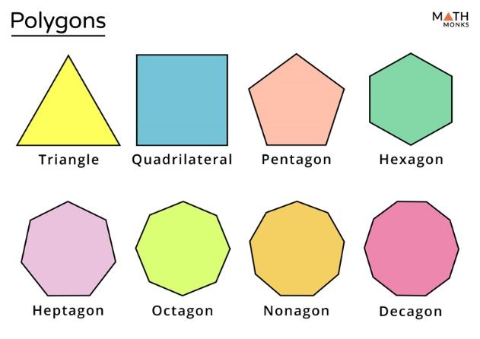

* You make a class “Polygon”.
  + One variable “color”
  + One property “Color”.
  + One constructor that sets the color.
* You make a class “Rectangle”.
  + Inherits from Polygon.
  + Two extra variables / properties.
    - Width.
    - Height.
  + One constructor to create a rectangle with a Width and a Height, with a certain color.
  + Two methods.
    - Area (and its functionality to calculate the area).
      * Width * Height.
    - Circumference (and its functionality to calculate the circumference).
      * 2 * Width + 2 * Height.
* You make a class “Square”.
  + Inherits from Rectangle.
    - Attention: A square is a special rectangle.
  + One constructor to create a Square with only one size (Width) and a certain color.
    - This sets the Width and Height for the rectangle.
* You make a class “RightTriangle”.
  + Inherits from Polygon.
  + Two extra properties.
    - Base. (one side of the right angle)
    - Height. (other side of the right angle)
  + One constructor to create a triangle with a Base and a Height, with a certain color.
  + Two methods.
    - Area (and its functionality to calculate the area).
      * (Base * Height) / 2.
    - Circumference (and its functionality to calculate the circumference).

|  |  |
| --- | --- |
|  |  |
|  | Do you have enough information on how to calculate this?  Look it up with internet. Think Pythagoras. |
|  |  |

### Variant 1

* Can you add a Circle to it?

## Exercise 13.03

* Create the classes thru a class diagram.
  + You don’t type them by yourself.
* The picture is shown below.
  + 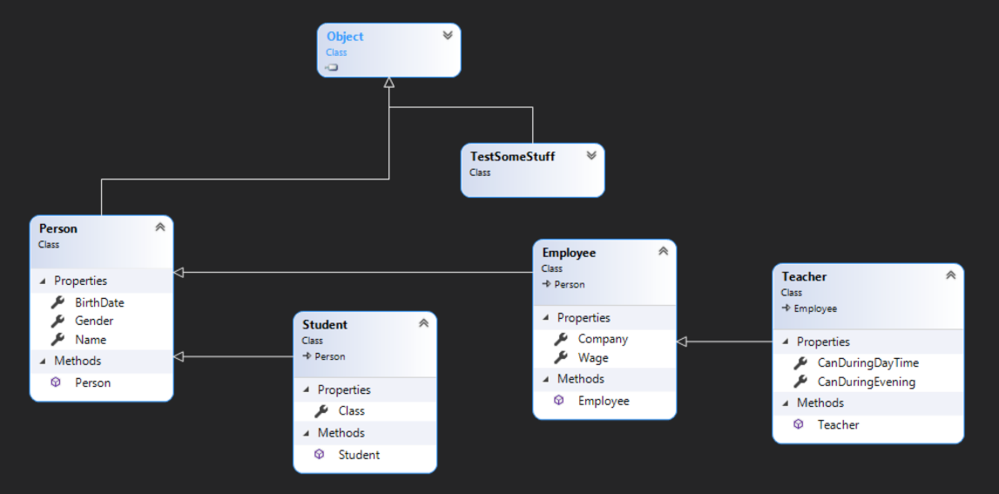Your classes will be generated by the tool.

## Exercise 13.04

* Create a class “Animal”.
  + Do the necessary stuff for making this.
  + It must have a method “Eat”, that shows “Animal is eating”.
* Create a class “Mammal”.
  + Do the necessary stuff for making this.
  + It inherits from Animal.
  + It must have a method “Eat”, that shows “Mammal is eating”.
* Create a class “Cat”.
  + Do the necessary stuff for making this.
  + It inherits from Mammal.
  + It must have a method “Eat”, that shows “Cat is eating mouse”.
* Create a class “Mouse”.
  + Do the necessary stuff for making this.
  + It inherits from Mammal.
  + It must have a method “Eat”, that shows “Mouse is eating cheese”.

## Exercise 13.05

* Create an abstract class “Shape”.
  + It has an empty constructor.
  + It has an abstract property “Name”.
  + It has a method “Area” that returns 0.
  + It has a method “Volume” that returns 0.
* Create a class “Point” that inherits from “Shape”.
  + It has 2 properties X and Y (the coordinates of a point).
  + The property Name returns “Point”.
  + It has a constructor with no parameters, where X and Y coordinates are 0.
  + It has a constructor with 2 parameters (X and Y coordinates).
  + You override the method “ToString” to show information about the point.
    - Show it in this format “[X, Y]”.
* Create a class “Circle” that inherits form “Point”.
  + It has 2 fields. The center and the radius.
  + It has 3 properties “Center” (this is a point), Radius and Name.
    - Radius can’t be negative. A negative value becomes 0.
    - The property Name returns “Circle”.
  + It has 3 constructors.
    - One with no parameters. This is a point on coordinates 0 and 0 with radius 0.
    - One with 3 parameters.
      * X coordinate.
      * Y coordinate.
      * Radius.
    - One with 2 parameters.
      * A point.
      * Radius.
  + You override the method Area that returns the Area of a circle.
  + You create a method that calculates the circumference.
  + You create a method that calculates the diameter.
  + You override the method “ToString” to show information about the circle.
    - You show the center, the radius, the Area and the diameter.
* Create a class “Cylinder” that inherits form “Circle”.
  + It has 2 fields. The base and the height.
  + It has 3 properties “Base” (this is a circle), Height and Name.
    - Height can’t be negative. A negative value becomes 0.
    - The property Name returns “Cylinder”.
  + It has 4 constructors.
    - One with no parameters. This is a circle on coordinates 0 and 0 with radius 0 and the height is 0.
    - One with 4 parameters.
      * X coordinate.
      * Y coordinate.
      * Radius.
      * Height.
    - One with 3 parameters.
      * A point.
      * Radius.
      * Height.
    - One with 2 parameters.
      * A circle.
      * Height.
  + You override the method Area that returns the Area of a cylinder.
  + You create a method that calculates the volume.
  + You create a method that calculates the area.
  + You override the method “ToString” to show information about the cylinder.
    - You show the center, the radius, the Area and the diameter and the volume.

## Exercise 13.06

|  |  |
| --- | --- |
|  |  |
|  | This is a very difficult exercise.  I must receive 2 things:   * A document in how to use the classes you have created. This document can contains example code in how to use the classes. * The classes itself. |
|  |  |

* You must invent and create an exercise by yourself.
* There must be inheritance in classes at least 3 levels deep.
  + Parent – Child – Child of child.
  + Inheritance must be implemented somewhere.
    - this and base must be used somewhere.
* Your namespace is “StudentTryout”.
* Your code will be treated as a Black Box.
  + Meaning.
    - I will create a testprogram using your classes.
    - I will not look inside the classes to create the test program.
  + I will do this:
    - “using StudentTryout”.
    - And see what is there and I will try to use it.

|  |  |
| --- | --- |
|  |  |
|  | Whatever I do, if the program fails it must be failing in my program, because I’m doing something stupid.  It never fails in your code. Everything that goes outside your classes and inside your classes behaves correctly like you have sent me the documentation. |
|  |  |

* After that. I will look inside your code just for trying stuff out, because a lot is possible, and see if I could have broken your code.